HOMEWORK SQL

- a. select all locations that have the capacity between 200 and 1000 persons

SELECT * FROM Locations WHERE Capacity between 200 AND 1000;

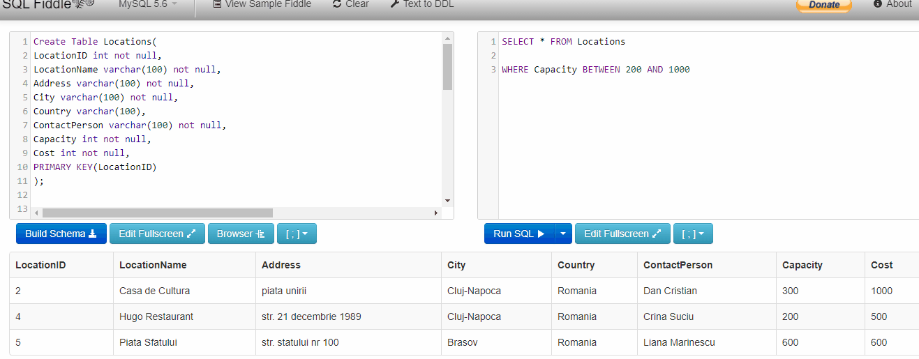

b. select all locations that have "a" in their name

SELECT * FROM Locations WHERE LocationName LIKE '%a%';

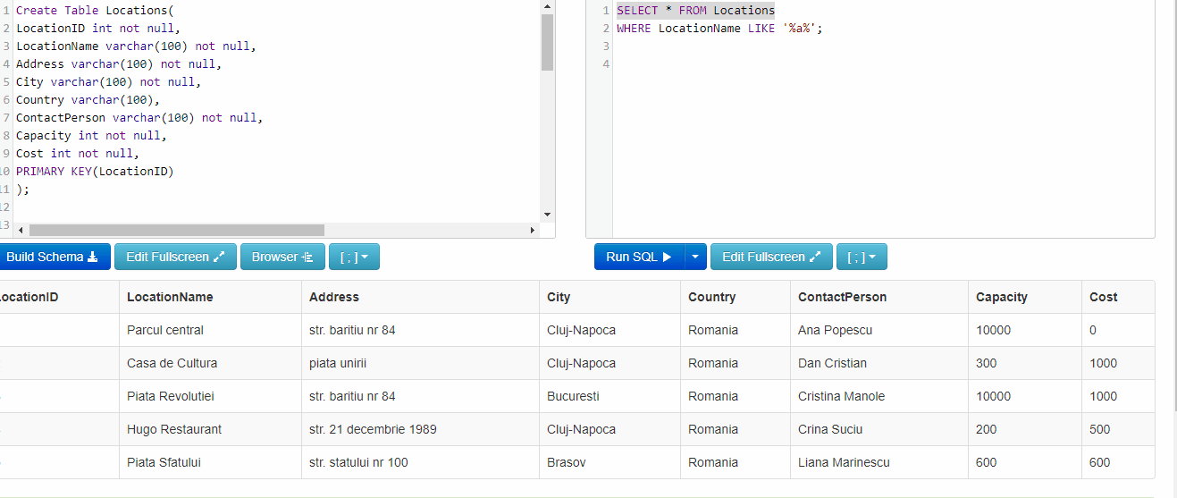

c. Select all locations that are not in Cluj-Napoca

SELECT * FROM Locations WHERE NOT (City = 'Cluj-Napoca');

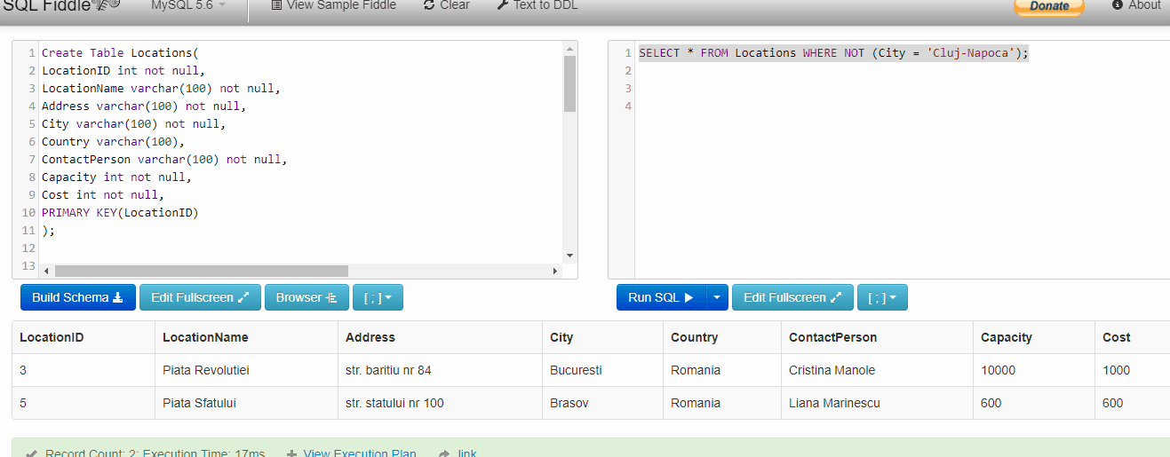

d. Select all locations that have the cost 0,500,600, are in Brasov and Cluj-Napoca, and han sustain a capacity greater that 1000 persons

SELECT * FROM Locations
WHERE (Cost = 0 OR Cost = 500 OR Cost=600) AND (City='Brasov' OR 'Cluj-Napoca')
AND Capacity > 1000;

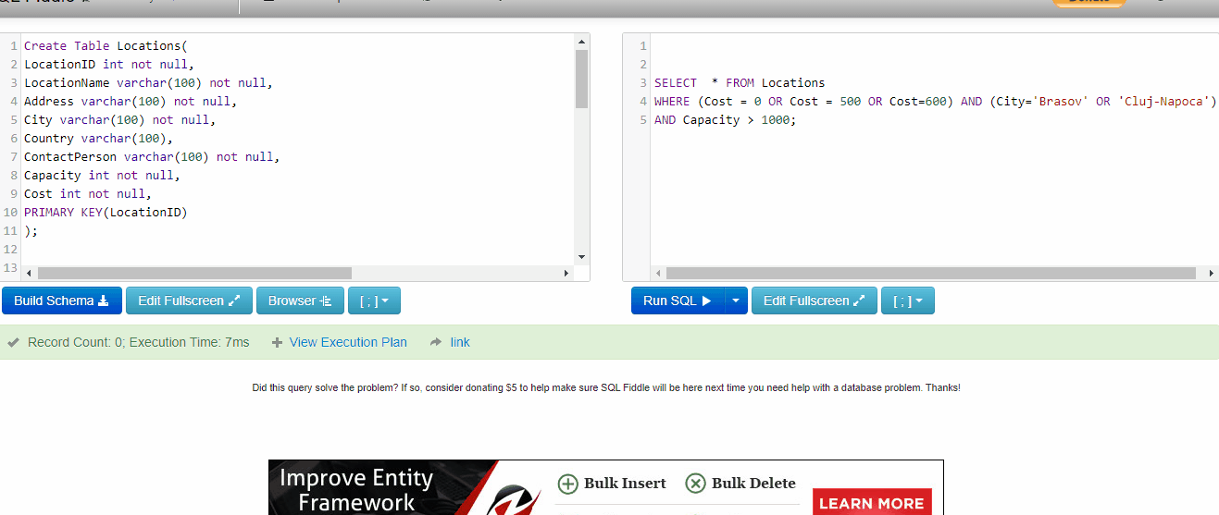

2. Perform the following queries on "Events" table:
a. return the results for min, max, average based on "EventCost" column

SELECT MIN(EventCost), MAX(EventCost), AVG(EventCost)
FROM Events

b. count how many events are associated to location 1 and 2

SELECT COUNT(*)
FROM Events
Where (LocationID = 1 AND LocationID = 2)

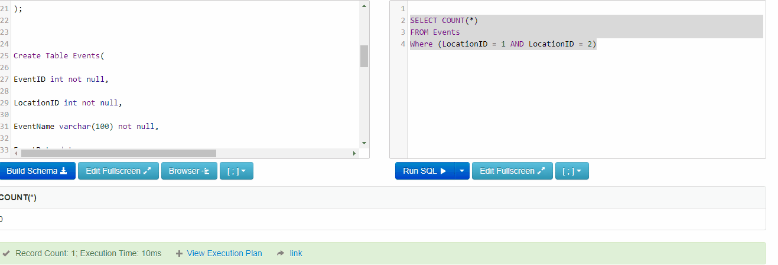

- compute the average cost obtained from location 1

SELECT AVG(EventCost)
FROM Events
WHERE LocationID=1;

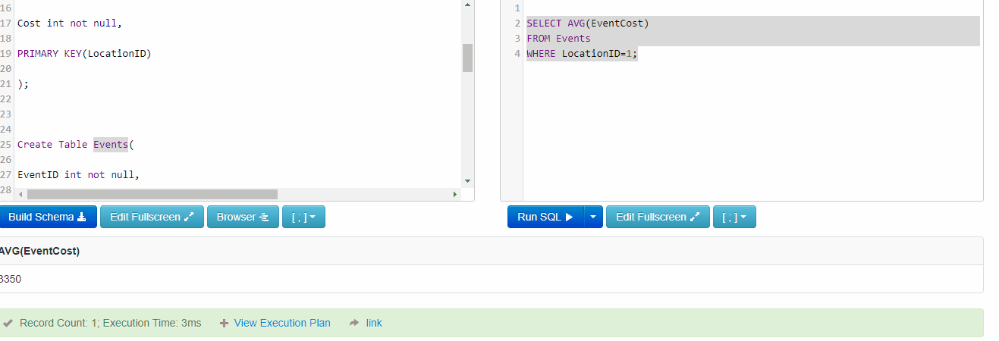

- order the events based on their defined date

SELECT * FROM Events
ORDER BY EventDate;

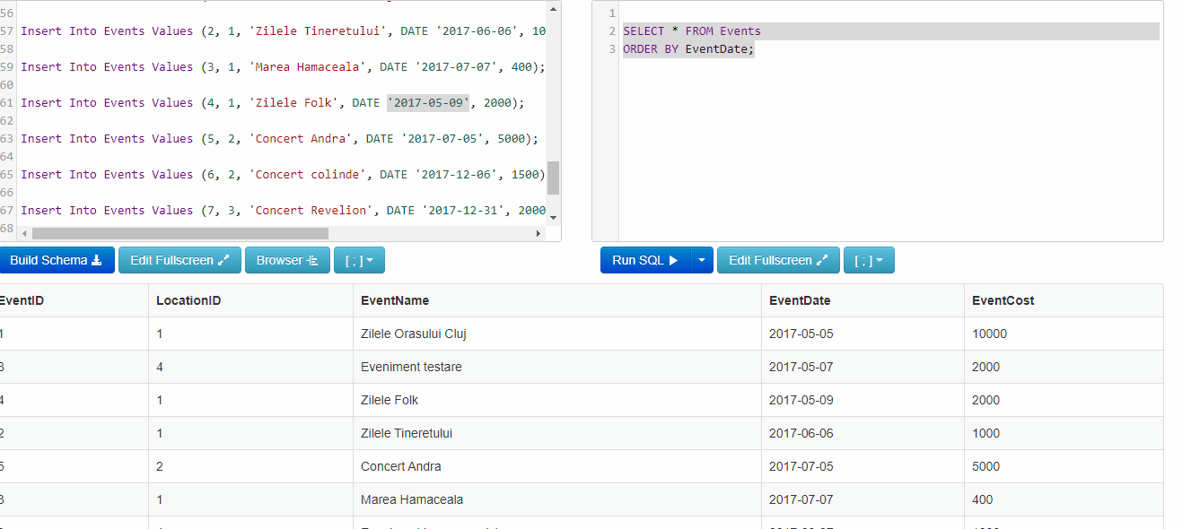

e. compute the total cost associated with each location (hint grouped by)

SELECT LocationID, SUM( EventCost)
FROM Events
GROUP BY LocationID;

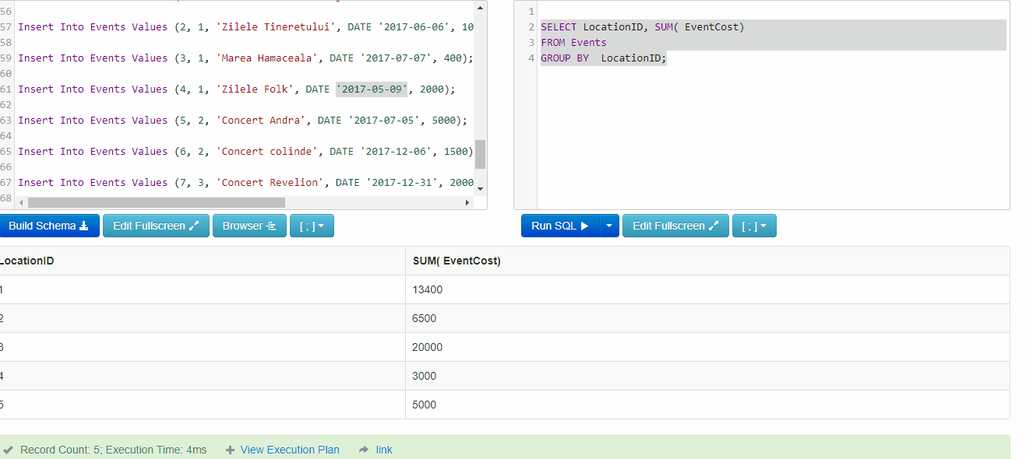

3. Perform the following queries using both tables

a. Order location name, descending, after their associated event cost

SELECT LocationName FROM Locations
INNER JOIN Events ON Events.LocationID= Locations.LocationID
ORDER BY EventCost DESC

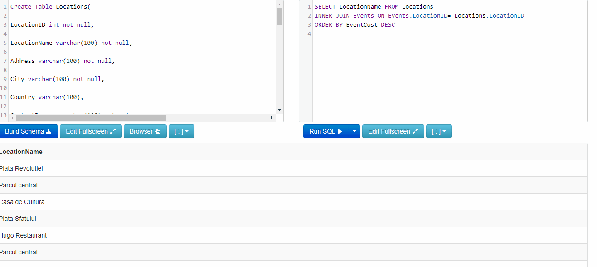

b. Select location name, location cost and event cost for a specific event

SELECT LocationName, SUM(EventCost) AS LocationCost, EventCost FROM Locations
INNER JOIN Events ON Events.LocationID = Locations.LocationID
WHERE EventName LIKE "Concert Revelion"

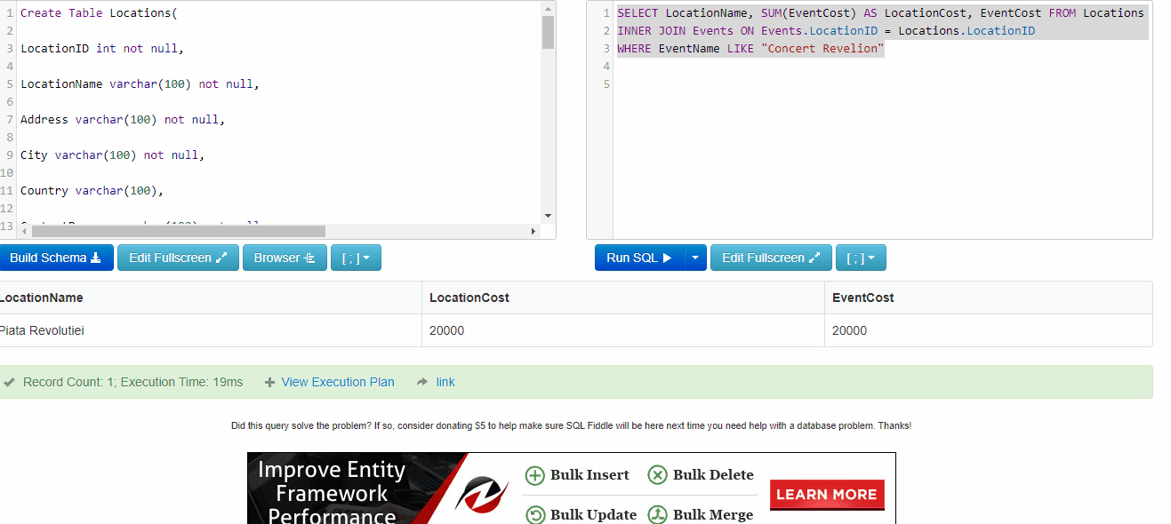

    - c. Return the first 3 events (with eventName, locationname), that have the greatest event cost, in alphabetical order (after their names)

SELECT EventName, LocationName, EventCost FROM Events
INNER JOIN Locations ON Events.LocationID = Locations.LocationID
ORDER BY LocationName ASC, EventCost DESC
LIMIT 3

